CLINICAL IMAGE

Title: Generalized Cutaneous neurofibromatosis with plexiform involvement
Authors information -Sai Pradeep Nallani [1]
Affiliation: MBBS, department of medicine [1]
Email- nspradeep99gmail.com
A. CASE DESCRIPTION
A 68- year- old female, presented to the hospital with complaint of swelling in anterior neck along with long standing, progressively increasing multiple skin lesions since early adulthood. On examination, numerous soft, skin coloured to hyperpigmented papules and nodules of varying size ranging from 3mm to more than 3cm distributed diffusely over neck, face, trunk, and upper extremities consistent with neurofibromas. In Addition, multiple well defined hyperpigmented macules were noted over axilla and trunk. A large, lobulated, pendulous mass involving chin and anterior neck region was observed, consistent with plexiform neurofibroma

B. DISCUSSION
Diagnostic criteria of Neurofibromatosis type -1 include any one of the following [1]:
- >2 neurofibromas or plexiform neurofibroma
- > 6 café-au-lait macules
- Axillary or Inguinal freckling
- Optic glioma
- >2 Lisch nodules
- Long bone dysplasia
- Any tumours in later stages includes pheochromocytoma
- A germline NF1 mutation
This case highlights a classical advanced cutaneous neurofibromatosis with plexiform neurofibroma. Yearly ophthalmology screening for optic glioma was conducted for every patient for early detection[1]
References
- https://www.ncbi.nlm.nih.gov/books/NBK1109/#_ncbi_dlg_citbx_NBK1109

Figure 1: Neurofibromas (plexiform neurofibroma also)
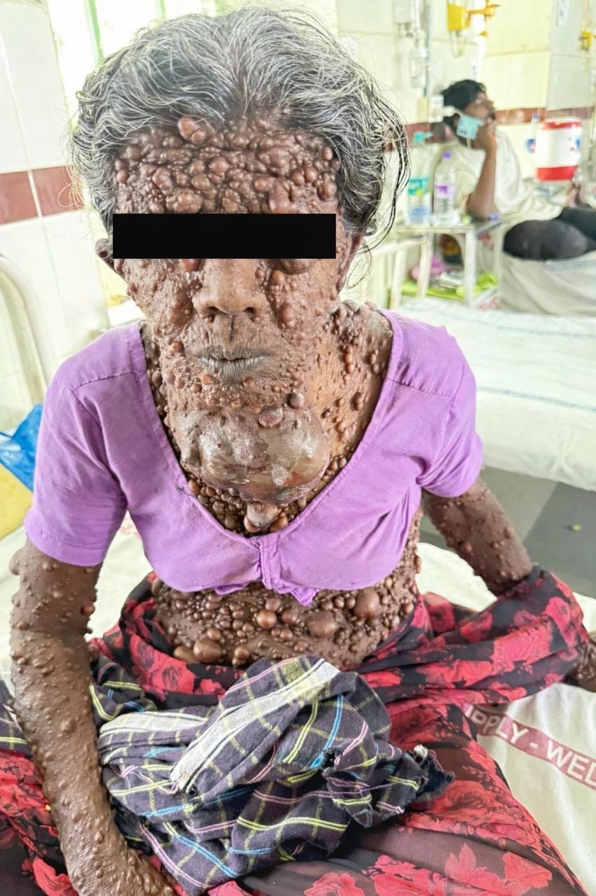

Figure 2,3: axillary freckles and café -au-lait macules
