Neonatal Osteogenesis Imperfecta Revealed by Antenatal Fractures: A Case Report

Anass Ayad ; Salahiddine Saghir , Mohamed Sellouti , , Rachid Abilkassem, a,b
a Neonatal Medicine and Intensive Care Unit, Mohammed V Military Teaching Hospital, Rabat, Morocco b Faculty of Medicine and Pharmacy, Rabat, Morocco

Abstract
Background: Osteogenesis imperfecta (OI) is a rare genetic disorder of connective tissue, primarily caused by mutations in the COL1A1 and COL1A2 genes encoding type I collagen.
Case presentation: We describe a male neonate diagnosed with OI after presenting with multiple antenatal and postnatal fractures. Prenatal ultrasound revealed intrauterine growth restriction and long-bone deformities. Postnatal clinical and radiological evaluations demonstrated diffuse osteopenia and multiple diaphyseal fractures. Genetic analysis identified a heterozygous COL1A2 (p.Gly358Ser) mutation consistent with type II OI. The patient was treated with intravenous zoledronic acid and showed good tolerance.
Conclusion: This case highlights the diagnostic and therapeutic challenges associated with severe neonatal OI. Early recognition, genetic confirmation, and multidisciplinary management are essential to improving survival and quality of life. Novel approaches—including anti-sclerostin antibodies, TGF-β inhibitors, and emerging gene-editing therapies—offer promising perspectives for the future management of this condition.
Keywords: osteogenesis imperfecta, antenatal fractures, bisphosphonates, zoledronic acid, neonatal bone fragility

Introduction
Osteogenesis imperfecta (OI) is a rare heritable connective tissue disorder characterized by defective synthesis of type I collagen, the major structural protein of bone. The condition results primarily from mutations in COL1A1 and COL1A2, which encode the α1 and α2 chains of type I collagen [1]. The estimated incidence of OI ranges from 1 in 15,000 to 20,000 live births [2].
Clinically, OI manifests with bone fragility, recurrent fractures, deformities, and growth retardation. Because type I collagen is widely expressed, extra-skeletal features may include dentinogenesis imperfecta, blue sclerae, hearing loss, respiratory impairment, and valvular heart disease [3].
The clinical spectrum ranges from mild forms compatible with normal life expectancy to perinatally lethal phenotypes. Antenatal detection of limb shortening or multiple fractures should raise suspicion of severe OI, warranting genetic confirmation and early multidisciplinary management

Case Presentation
A male neonate was delivered at term (39 weeks’ gestation) with Apgar scores of 9/10/10. Birth weight was 2550 g (1.5th percentile), length 42 cm (<1st percentile), and head circumference 34 cm (29th percentile). Amniotic fluid was clear, and there was no evidence of maternal infection. The 32-year-old mother (G7P4) had a complex obstetric history: two healthy children (G1–G2), one intrauterine fetal death at seven months due to anhydramnios (G3), one term delivery complicated by gestational diabetes (G4), and two spontaneous miscarriages (G5–G6).
The current pregnancy was complicated by intrauterine growth restriction and lower limb deformities, with femoral length at the 3rd percentile at 27 weeks and overall fetal growth at the 1st percentile by 37 weeks (Figure 1). The mother had a history of postpartum stroke after her third delivery, previously treated with anticoagulants. There was no consanguinity.

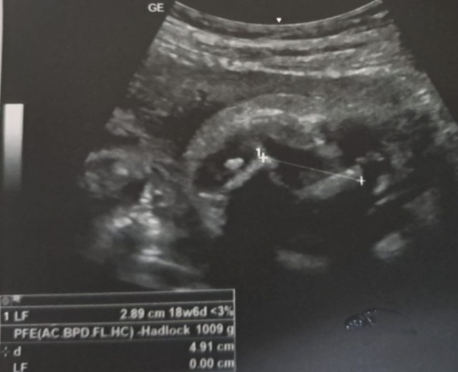
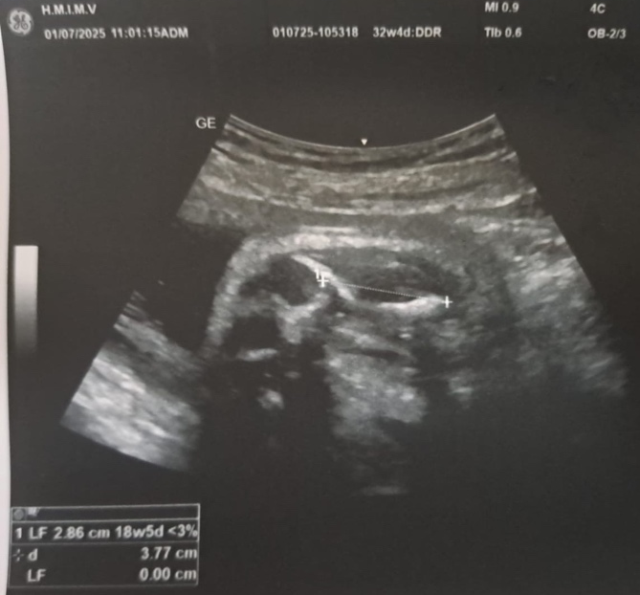
Figure 1. Prenatal ultrasound showing reduced femoral length and curved lower limbs.
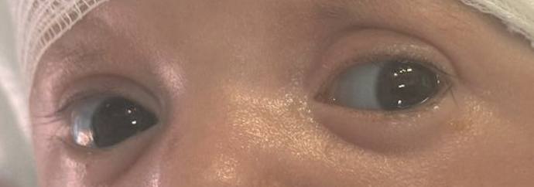
At birth, the neonate was peripherally hypotonic but reactive. He exhibited intense pain on limb manipulation, with audible crepitus over the long bones of the left upper and lower extremities. The limbs were flaccid and tender to touch. The skull was soft with widened cranial sutures. Other systemic findings were unremarkable (Figure 2).
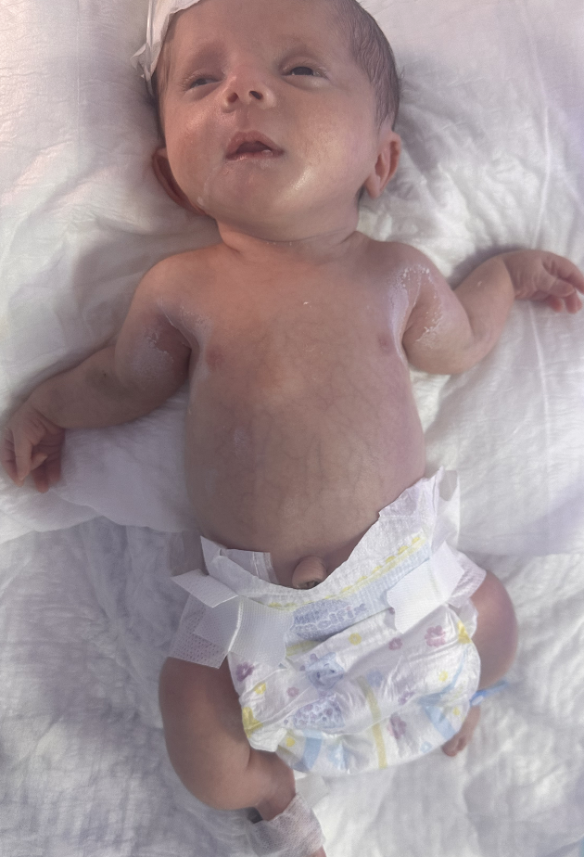

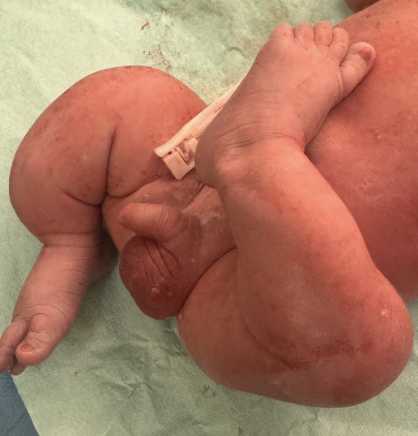

Figure 2. Phenotypic features: shortened, deformed lower limbs and blue sclerae.
Radiographs revealed multiple non-displaced fractures of the upper third of both humeral diaphyses and the mid-third of the femoral shafts (Figure 3). Cranio-cervical CT demonstrated turribrachycephaly (cranial index 130), severe osteopenia with extreme thinning of calvarial bones, widened sutures, and diffuse bone erosions. The odontoid process was poorly visualized, suggesting delayed ossification or partial agenesis. No craniosynostosis or intracranial abnormality was noted . Echocardiography revealed a small membranous ventricular septal defect.
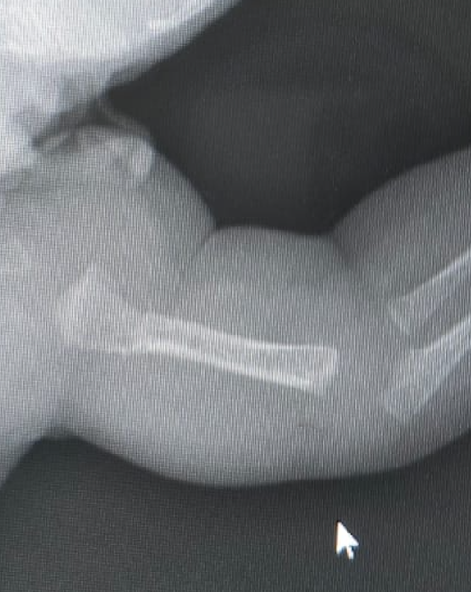
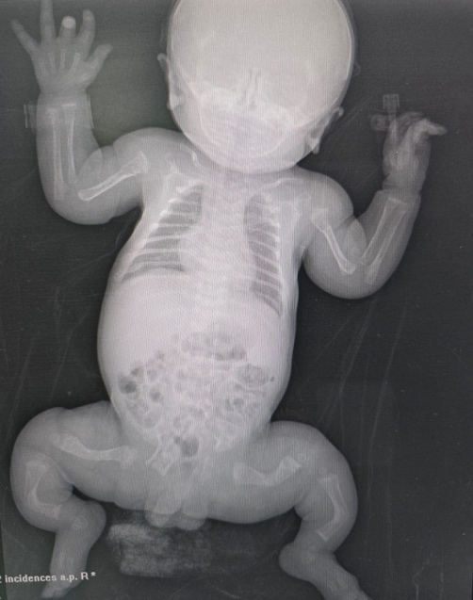
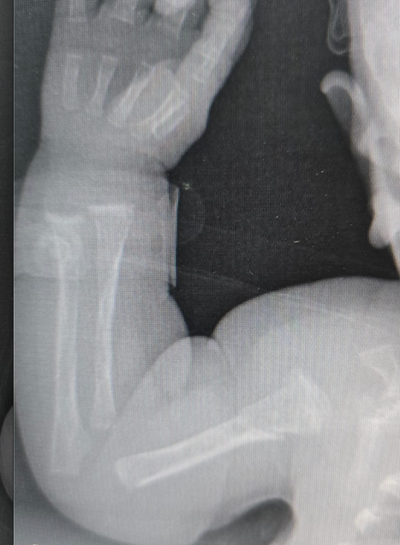

Figure 3. Standard X-ray showing multiple diaphyseal fractures of the humeri and femora..

Laboratory findings were as follows: calcium 87 mg/L, phosphorus 53 mg/L, alkaline phosphatase 143 IU/L, and parathyroid hormone 24 pg/mL. Genetic testing confirmed a COL1A2 (p.Gly358Ser) mutation, consistent with type II OI.
The patient initially received analgesic treatment with paracetamol, but due to persistently elevated EDIN score , continuous pain management was escalated to intermittent morphine infusion. Morphine was administered under close monitoring, with progressive tapering as the patient’s pain improved. No withdrawal symptoms were observed during or after weaning.
The patient received calcium and vitamin D supplementation and was treated with intravenous zoledronic acid (0.05 mg every six months, first dose at day 42 of life). The treatment was well tolerated; transient post-infusion fever occurred without hypocalcemia.
Short-term follow-up showed no new fractures. An orthopedic intervention is planned to address the previously healed fractures and residual deformities. At the time of reporting, no analgesic medication was required, and the infant remained clinically stable.

DISCUSSION :

Osteogenesis imperfecta (OI) is a heterogeneous hereditary disorder of connective tissue caused mainly by mutations in the COL1A1 and COL1A2 genes, which encode the α1 and α2 chains of type I collagen. Defective synthesis or altered structure of type I collagen results in abnormal bone matrix formation and increased bone fragility. The clinical spectrum is broad, ranging from mild forms characterized by recurrent fractures and normal stature to severe perinatal-lethal types associated with multiple antenatal fractures, skeletal deformities, and respiratory failure. The incidence of OI is estimated at 1 in 15,000 to 20,000 births, but its true frequency may be underestimated due to early fetal loss and diagnostic challenges in low-resource settings [1].
In recent years, advances in prenatal imaging and molecular genetics have considerably improved the understanding and diagnosis of OI. Antenatal ultrasound plays a pivotal role in the early detection of severe skeletal dysplasias. Typical features suggestive of OI include limb shortening, bowing or angulation of long bones, multiple fractures, micromelia, and decreased calvarial ossification leading to compressible skull bones. These findings can be detected as early as the second trimester and are often accompanied by intrauterine growth restriction. However, differential diagnosis with other skeletal dysplasias such as thanatophoric dysplasia, hypophosphatasia, and campomelic dysplasia can be difficult, highlighting the importance of molecular confirmation. The identification of a pathogenic variant in COL1A1 or COL1A2 confirms the diagnosis and provides crucial information for genetic counseling and prognostication [2,3].
Our case aligns with several recent reports describing antenatal detection of limb deformities and multiple fractures later confirmed as OI type II. Timila et al. (2025) reported a neonate with multiple intrauterine fractures who survived after early multidisciplinary intervention [4]. Peláez Chomba et al. (2023) described a prenatal diagnosis in a resource-limited setting, emphasizing the ethical and emotional complexity surrounding parental decision-making in severe OI [5]. Vankevičienė et al. (2023) documented a sporadic COL1A1 mutation detected prenatally, reinforcing the significance of genotype–phenotype correlation [6]. Carroll et al. (2025) reviewed a cohort of prenatally diagnosed infants and demonstrated that many of these neonates survived beyond the first months of life, challenging the long-held belief that type II OI is uniformly lethal [7]. These findings collectively highlight the value of antenatal diagnosis in anticipating postnatal complications, planning delivery in a specialized neonatal unit, and initiating early management.
The clinical management of neonatal OI is complex and requires a coordinated multidisciplinary approach. Immediate priorities after birth include gentle handling to avoid iatrogenic fractures, adequate pain control, respiratory support if required, and genetic confirmation. Pain management is particularly important, as neonates with OI experience persistent discomfort related to multiple fractures and skeletal deformities. Behavioral scales such as the EDIN (Neonatal Pain and Discomfort Scale) are valuable tools for assessing prolonged pain in this population. In our patient, analgesia was initiated with paracetamol but was escalated to intermittent morphine infusion due to persistently elevated EDIN scores. Morphine was gradually tapered as pain decreased, and no withdrawal symptoms were observed. This individualized approach ensured effective pain control during the acute phase, allowing comfortable mobilization and care.
Among pharmacologic therapies, bisphosphonates have emerged as the cornerstone of medical treatment in moderate-to-severe OI. By inhibiting osteoclast-mediated bone resorption, these agents increase bone mineral density and decrease the rate of new fractures. Glorieux et al. were the first to report the efficacy of cyclical intravenous pamidronate in children with OI, showing improvements in mobility, vertebral shape, and pain reduction [8]. More recently, zoledronic acid has gained interest as an alternative due to its higher potency, shorter infusion time, and longer dosing interval. Timila et al. (2025) and Arundel et al. (2023) reported successful use of zoledronic acid in infants, with improved bone density and decreased fracture incidence within months of therapy initiation [4,9]. In our patient, intravenous zoledronic acid was started at 42 days of life and was well tolerated, producing no hypocalcemia or metabolic disturbances. This early initiation appears to support bone stabilization and may help reduce the frequency of subsequent fractures.
Despite these advances, OI remains a lifelong condition requiring ongoing orthopedic, rehabilitative, and psychosocial support. The prognosis depends on the genetic variant, the severity of skeletal and respiratory involvement, and the quality of multidisciplinary care. Historically, type II OI was considered incompatible with life, but recent data indicate a trend toward increased survival with aggressive supportive management. In Carroll’s 2025 cohort, several infants initially labeled as “lethal” survived into childhood with variable degrees of functional independence [7]. Medium- and long-term follow-up of treated patients demonstrates improved bone density, reduced fracture frequency, and enhanced quality of life. Nevertheless, these children often face persistent challenges such as growth retardation, scoliosis, recurrent fractures, and chronic pain.
Future therapeutic perspectives are promising. Beyond bisphosphonates, novel approaches such as anti-sclerostin antibodies, transforming growth factor-β (TGF-β) inhibitors, mesenchymal stem cell transplantation, and gene-editing techniques are under investigation and may offer disease-modifying or even curative potential in the coming years [10]. Early identification, precise genetic characterization, and proactive multidisciplinary management remain the key determinants of survival and functional outcome.
In summary, this case adds to the growing evidence that early diagnosis and timely intervention can significantly alter the prognosis of severe neonatal OI. Antenatal recognition enables appropriate delivery planning and parental counseling, while early initiation of bisphosphonate therapy, optimized analgesia, and orthopedic follow-up contribute to improved comfort and quality of life. The evolution of therapeutic strategies continues to transform this once-lethal disorder into a condition compatible with longer survival and meaningful functional improvement.

References:
- Marini JC, Forlino A. Osteogenesis imperfecta. Nat Rev Dis Primers. 2017;3:17052.
- Rauch F, Glorieux FH. Osteogenesis imperfecta. Lancet. 2004;363(9418):1377–85.
- Forlino A, Marini JC. Osteogenesis imperfecta: prospects for molecular therapeutics. N Engl J Med. 2016;375:256–65.
- Timila D, et al. Holistic approach to management of an infant with severe osteogenesis imperfecta in the NICU. Front Pediatr. 2025;13:1438124.
- Peláez Chomba MS, et al. A prenatal diagnosis of osteogenesis imperfecta in a low-resource setting. F1000Research. 2023;12:603.
- Vankevičienė K, et al. A sporadic case of COL1A1 osteogenesis imperfecta. Genes. 2023;14(11):2062.
- Carroll RS, et al. Most infants with prenatal OI diagnosis survive to discharge. JBMR Plus. 2025;9(4):ziaf022.
- Glorieux FH, et al. Cyclic administration of pamidronate in children with severe osteogenesis imperfecta. N Engl J Med. 1998;339:947–52.
- Arundel P, et al. Early life management of osteogenesis imperfecta. Curr Osteoporos Rep. 2023;21:189–202.
- Dwan K, Phillipi CA, Steiner RD. New and emerging therapies in osteogenesis imperfecta. Front Endocrinol (Lausanne). 2023;14:1123345

